**Dear {fn} {ln},**

**The information below will help you prepare for your end of year exams**

**User Information Displayed Below:**

**Grade Level: {gl}**

**Student Number: {sn}**

**AICE Exams:** {al}

**AP Exams:** {ap}

AICE Exams are usually divided into two papers that will be taken on different days while AP exams are one day exams.

## **AICE Marine AS:**

**Paper 1: Apr 24, 2023 – 1 hour: 45 mins PM.**

**Paper 2: Apr 27, 2023 – 1 hour: 45 mins PM.**

**Total Time: 210 Minutes**

## **AICE Thinking Skills AS:**

**Paper 1: Apr 24, 2023 – 1 hour: 30 mins PM.**

**Paper 2: Apr 28, 2023 – 1 hour: 45 mins PM.**

**Total Time: 195 Minutes**

## **AICE English General Paper AS:**

**Paper 1: Apr 25, 2023 – 1 hour: 15 mins AM.**

**Paper 2: Apr 27, 2023 – 1 hour: 45 mins AM.**

**Total Time: 180 Minutes**

## **AICE Psychology AS:**

**Paper 1: Apr 25, 2023 – 1 hour: 30 mins AM.**

**Paper 2: Apr 27, 2023 – 1 hour: 30 mins AM.**

**Total Time: 180 Minutes**

## 

## **AICE Travel & Tourism AS:**

**Paper 1: Apr 25, 2023 – 2 hour: 30 mins PM.**

**Paper 2: None**

**Total Time: 150 Minutes**

## **AICE English Language AS:**

**Paper 1: Apr 26, 2023 – 2 hour: 15 mins AM.**

**Paper 2: Apr 28, 2023 – 2 hour: 00 mins AM.**

**Total Time: 255 Minutes**

## **AICE Global Perspectives AS:**

**Paper 1: Apr 26, 2023 – 1 hour: 30 mins AM.**

**Paper 2: None**

**Total Time: 90 Minutes**

## **AICE Environmental Management AS:**

**Paper 1: Apr 26, 2023 – 1 hour: 45 mins PM.**

**Paper 2: May 1, 2023 – 1 hour: 45 mins PM.**

**Total Time: 210 Minutes**

## **AICE History AS:**

**Paper 1: May 2, 2023 – 1 hour: 15 mins PM.**

**Paper 2: May 4, 2023 – 1 hour: 45 mins PM.**

**Total Time: 180 Minutes**

## **AICE Mathematics AS:**

**Paper 1: May 3, 2023 – 1 hour: 50 mins PM.**

**Paper 2: May 5, 2023 – 1 hour: 15 mins PM.**

**Total Time: 185 Minutes**

## **AICE Media Studies AS:**

**Paper 1: May 4, 2023 – 2 hour: 00 mins AM.**

**Paper 2: None**

**Total Time: 120 Minutes**

## **AICE Literature in English AS:**

**Paper 1: May 12, 2023 – 2 hour: 00 mins AM.**

**Paper 2: May 19, 2023 – 2 hour: 00 mins AM.**

**Total Time: 240 Minutes**

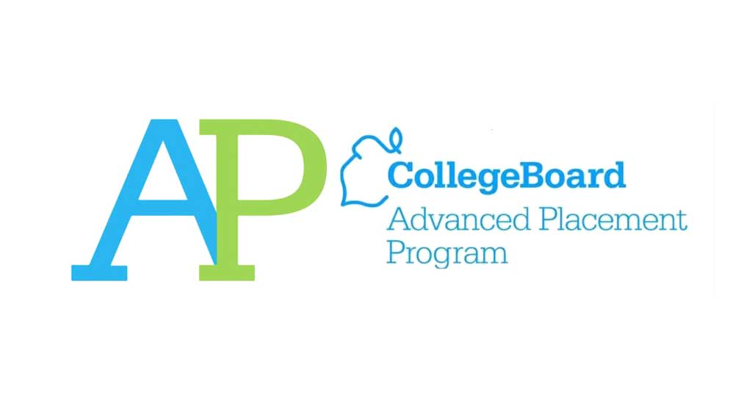

## **AP US Government & Politics Exam:**

**Date: May 1, 2023 – 3 hours AM.**

**Total Time: 180 Minutes**

## **AP Psychology(FLVS) Exam:**

**Date: May 2, 2023 – 2 hours PM.**

**Total Time: 120 Minutes**

## **AP Human Geography(FLVS) Exam:**

**Date: May 4, 2023 – 2 hours: 15 mins AM.**

**Total Time: 120 Minutes**

## **AP Macroeconomics(FLVS) Exam:**

**Date: May 4, 2023 – 2 hours: 10 mins AM.**

**Total Time: 120 Minutes**

## **AP Statistics Exam:**

**Date: May 4, 2023 – 3 hours PM.**

**Total Time: 120 Minutes**

## **AP Art History (FLVS) Exam:**

**Date: May 5, 2023 – 3 hours PM.**

**Total Time: 120 Minutes**

## **AP Calculus AB/BC Exam:**

**Date: May 8, 2023 – 3 hours AM**

**Total Time: 120 Minutes**

## **AP Computer Science Principles Exam:**

## **Date: May 8, 2023 – 2 hours PM.**

**Total Time: 120 Minutes**

## **AP Spanish Language & Culture Exam:**

## **Date: May 10, 2023 – 3 hours AM.**

**Total Time: 120 Minutes**

## **AP Biology Exam:**

**Date: May 10, 2023 – 3 hours PM.**

**Total Time: 120 Minutes**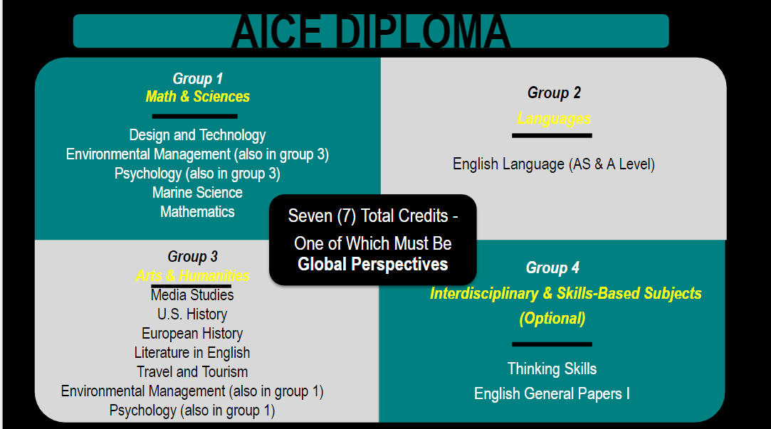

If you have any questions regarding these exams, AICE examination, or AP examination. Please contact Mrs. Skowron through an email regarding your questions:

[**marlaina.skowron@palmbeachschools.org**](mailto:marlaina.skowron@palmbeachschools.org)